DATA WAREHOUSE PROJECT

= ETL - Stands for Extract,Transform, Load - it is process used to extract data inorder to extract the data from the sources and apply multiple sources to it and stores it in the data warehouse.

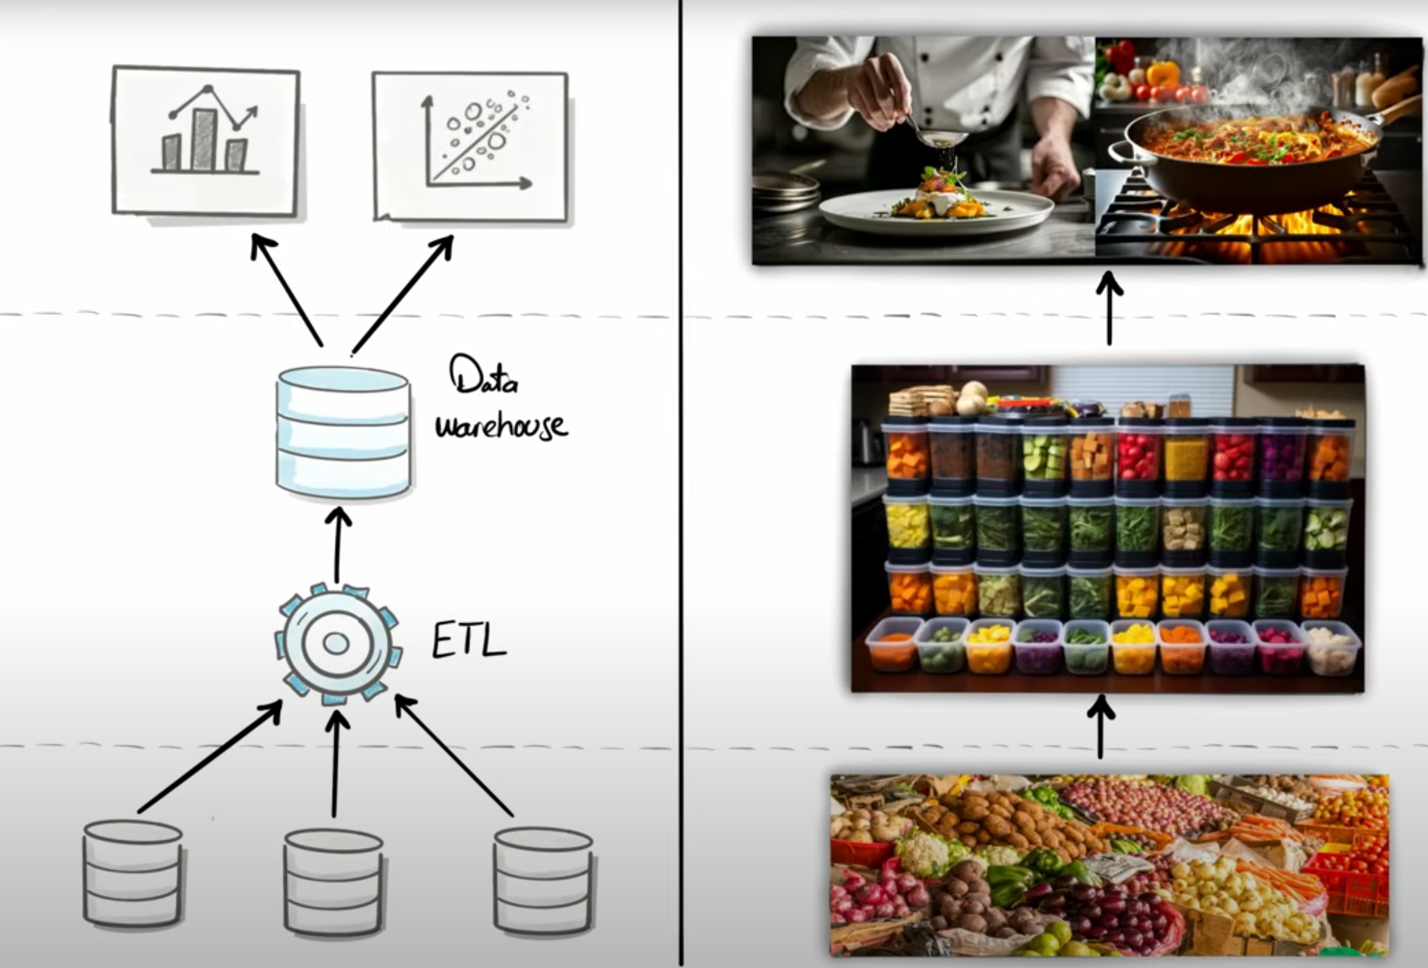

Steps in ETL

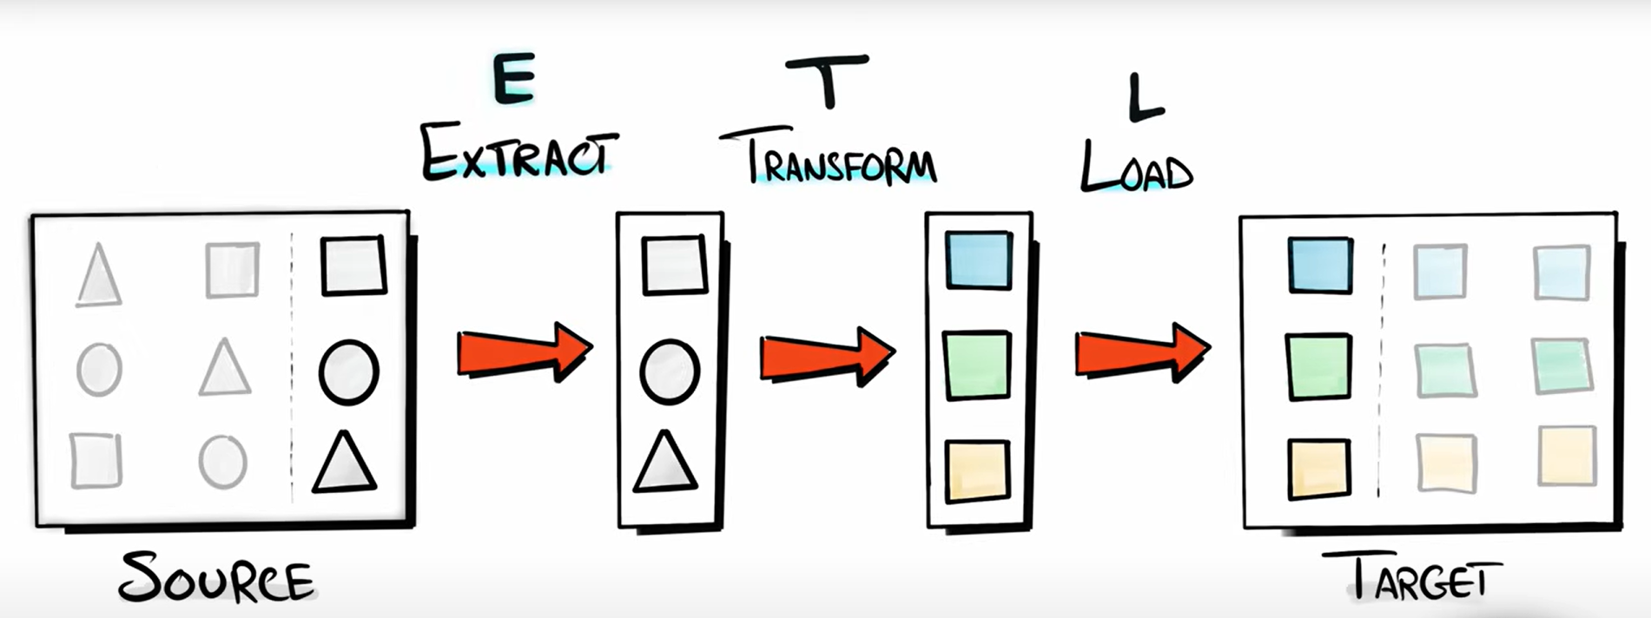

Data Architecture

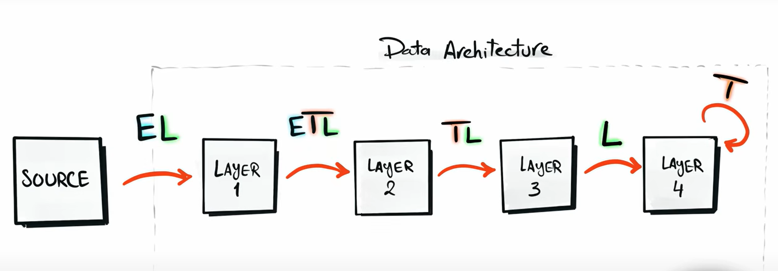

ETL Arrchitecture

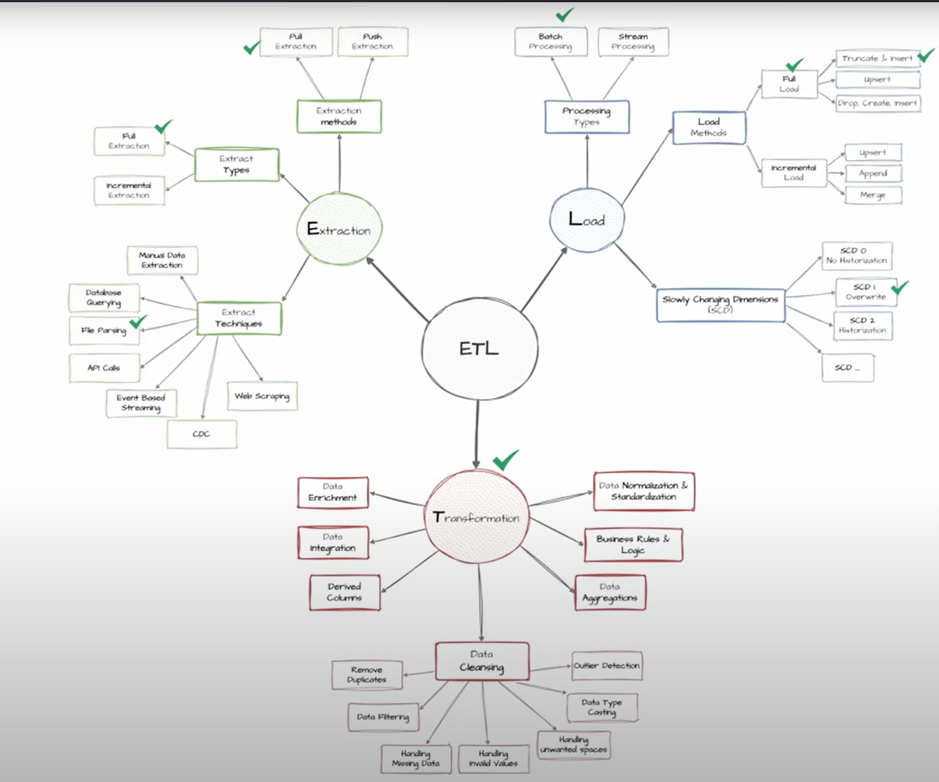

To Do a Data projects We have to Follow these steps  
  
1.To Design Architecture

------Types of Data Architectures-------  
  
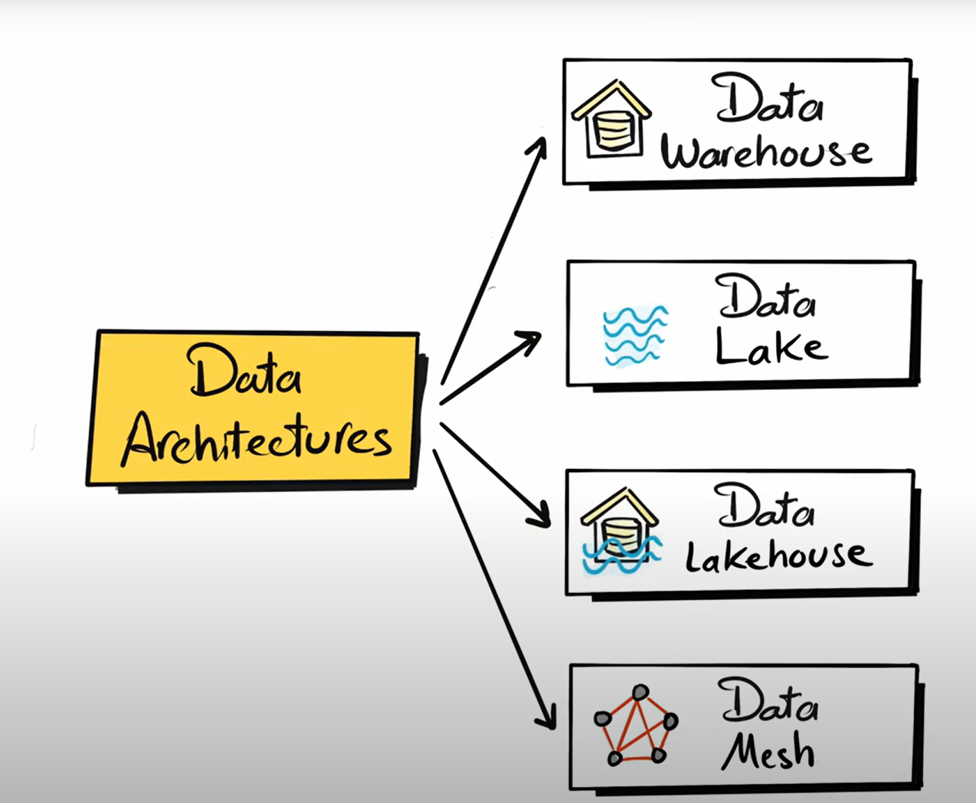

Four Approaches to build a Data Warehouse  
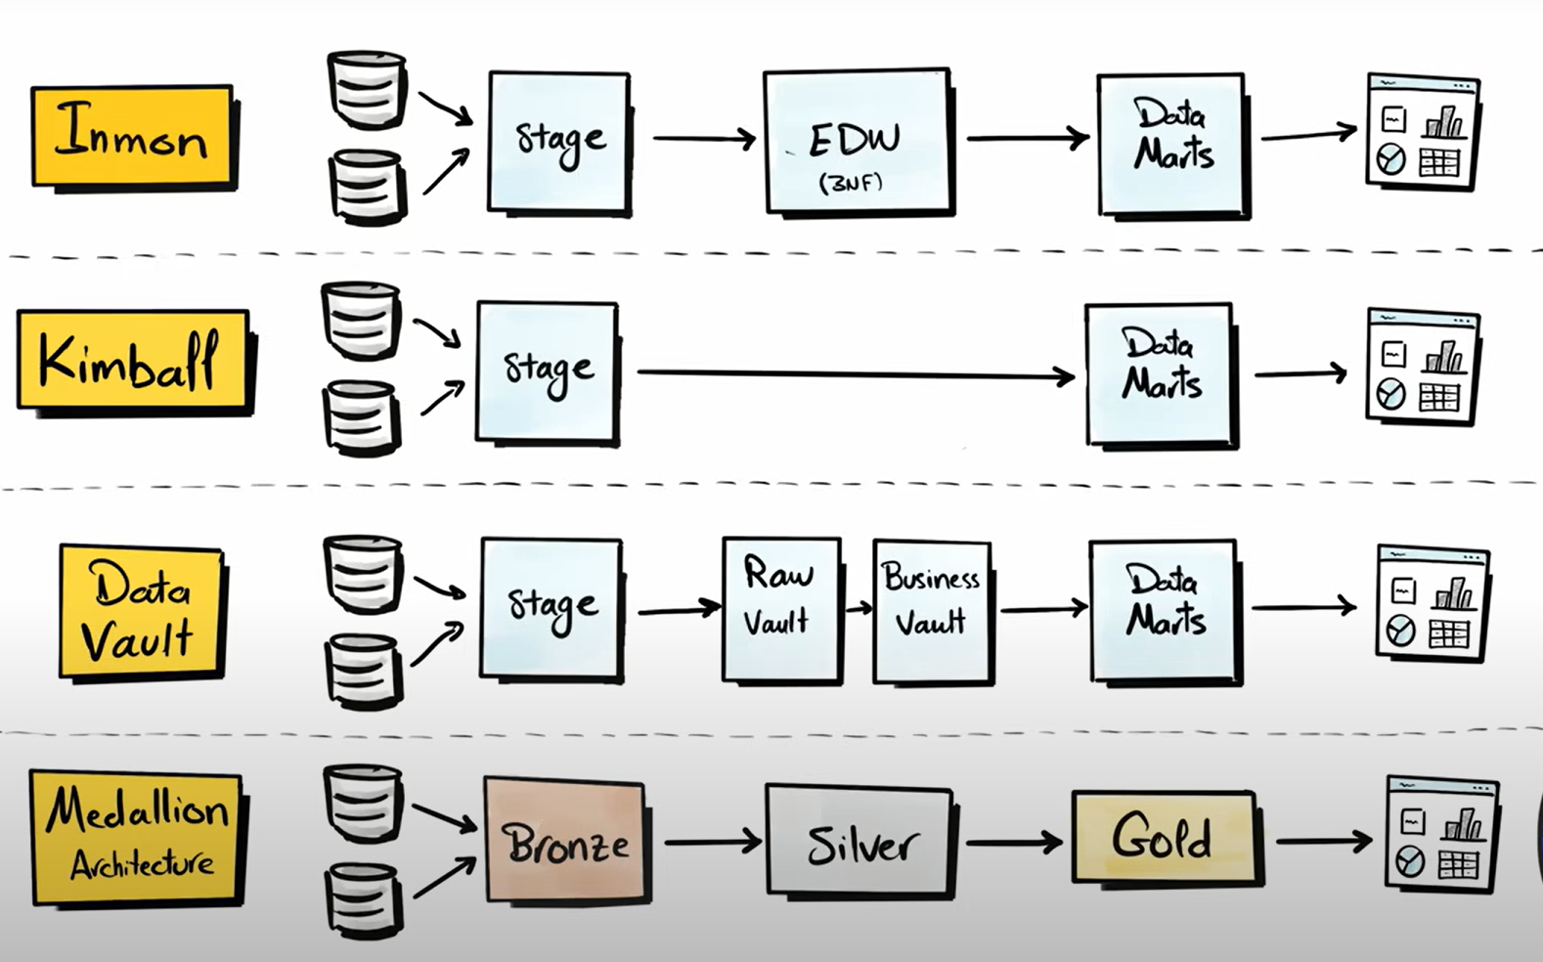

---------- Here we are using Medallion Architecture for Designing our Layers--------

= Bronze Layer – here it contains raw data for debugging and traceability

= Silver Layer – here we are storing the cleaned and standardized data, here we do basic transformations

= Gold Layer – it contains business ready data

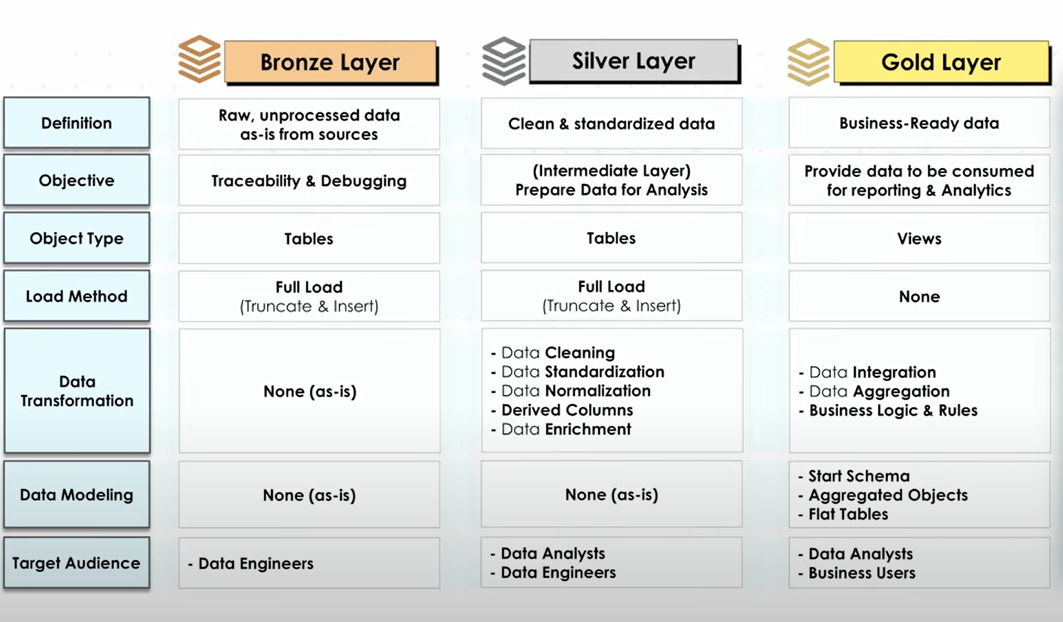

SOC (Separation of concerns)  
  
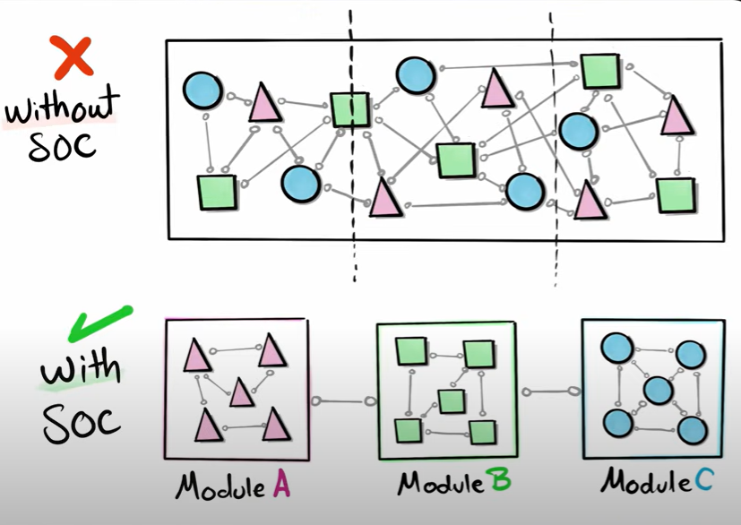

Then we have to Draw the Architecture using (Draw.io)

----- after that we have to do naming convention

-----after that we have to create a git repo